MAG 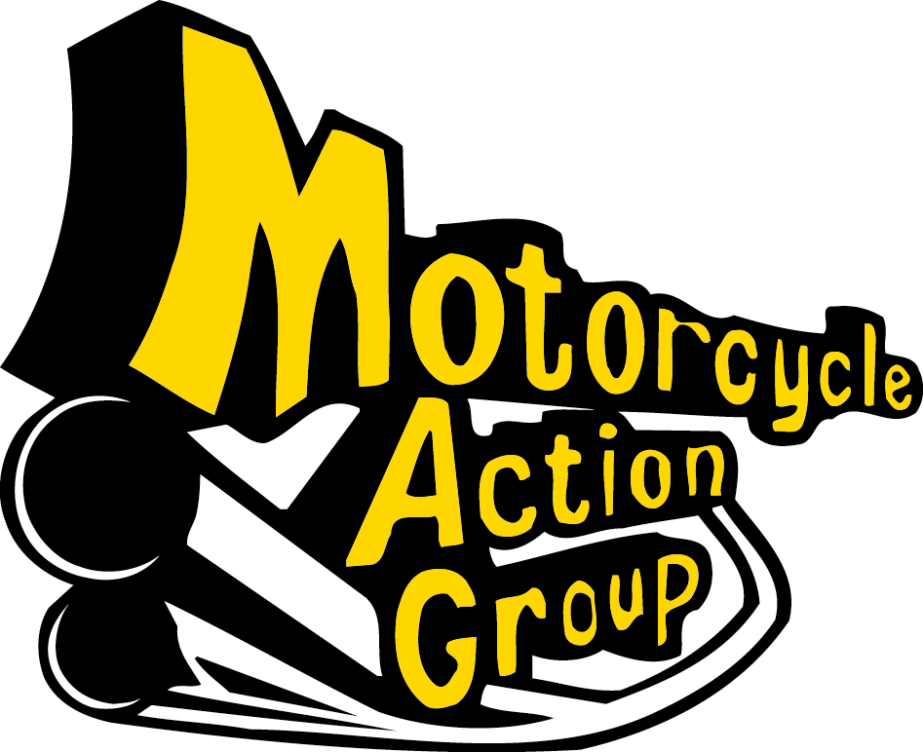
EVENT
TODAY

Slough Council : This notice will be removed within 24 hours

